A Step-By-Step Guide to Finding and Buying

an Off-Market Home

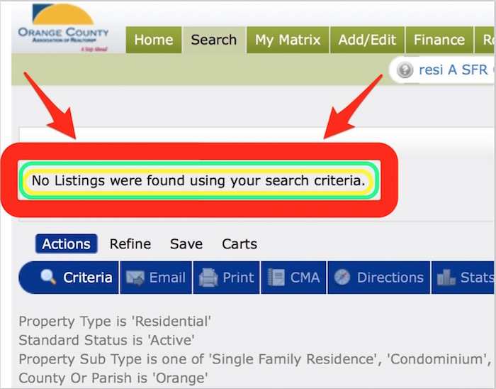

The biggest reality confronting today's homebuyers: Lack of inventory.

A solution to the problem: Finding and then buying an off-market home.
If you're reading this you are probably frustrated by not having found a home that you'd like to buy.
You also may be getting daily/hourly updates and emails on market activity and new listings from numerous agents, Zillow, Trulia, and more. But, for whatever reason, it's just not working.
There is another option and you can even do it yourself!
Finding and buying an off-market home isn't easy to do, but it's certainly possible and can result in finding a home without having to compete with other buyers in the same situation. You can do this yourself or you can hire us to do it for you, utilizing our Wise Home Buyer program.
The basic premise of the process is to identify a property that you would like to buy that isn't listed for sale on the local Multiple Listing Service (MLS) and then convince the owner to sell it to you. It turns the typical process of home buying (examining what's on the market and decide which one you want) on its head: you'll be identifying homes that you could potentially want and then making an attempt to buy one.
These are the steps to follow if you want to give it a go:

Step 1: Get Fully Pre Approved
This is a KEY first step.
Whatever your level of motivation and intent, before thinking about looking at homes, you need to know the price range that you can afford. More importantly, before talking to a homeowner about buying their home, you need to have your financing totally prearranged. To use an oft-overused analogy, you want to have your gun fully loaded. This will include submitting a full loan application package to a lender for their evaluation and then getting a pre-approval letter in return.
Do not make the mistake of assuming what kind of home you can buy or having a quick pre-qualification discussion with a lender.
Part of the strategy in buying an off-market property will be to convince the potential seller that you are a bona fide buyer. In today's market, every homeowner is getting bombarded by Realtors asking them if they'd like to sell or telling them they "have buyers looking for homes in the neighborhood" - all of this is just prospecting for listings. You will need to set yourself a part and the first step is to be able to convince them that you literally have money in the bank that you're ready to part with for their home. Unless you're paying cash, having a loan fully pre approved is the next best thing.
The first step in the process of getting approved by a lender is doing your own financial homework. Go FreeScoreOnline to get your 3 credit scores, go to AnnualCreditReport.com to get copies of your credit report, and then take any necessary steps to correct and errors or problems. We can help you with that.
Part of understanding your credit qualifications is precisely knowing your monthly debts.
Any credit card, revolving account, car or school payment, alimony or child support, and/or any other monthly obligation will contribute to your debt-to-income calculations. It’s a rare person, in my experience, that can accurately estimate the total of their monthly obligations. So don’t estimate yours, if you want to wisely shop loans. Get all of your recent monthly statements and put together a detailed list that includes the payee, monthly minimum required payment, and total outstanding obligation.
Furthermore, make sure you fully understand how a lender will evaluate your income and be prepared for a detailed conversation.
For some, this is easy. If you’re a salaried individual with no bonuses, commissions, or over-time pay, it’s simple. But if your income includes any of these variables, it’s more complicated. If you’re self-employed, it’s even more complicated. Before you have a conversation with a lender, have at hand copies of all of your income documentation: W2s, 1099s, federal tax forms, social security and/or pension award letters and statements, and a month’s worth of pay stubs.
It's also very wise to distinguish between what you'll be qualified to spend and what you'd actually want to spend.
It's possible that you may qualify for more home (requiring more cash and monthly payments than you want to spend). Make sure you understand the consequences of whatever figures you decide upon, including cash-to-close requirements and ongoing monthly housing expenses.
I just recently closed a purchase for a family that on paper could have afforded a much larger purchase, for example, but they decided that the peace of mind of maintaining significant cash reserves and a lower monthly house expense was far more important for them than pushing their home-buying envelope.
Of course, we can help you get your loan pre approved and arrange for the best available rates and terms in the market place go to WiseHomeBuyer.HausamGroup.com to get started.

Step 2: Start Preparing to Talk to Homeowners
At some point you'll have a conversation with a homeowner and you want to have this part down pat. So start thinking about it now. This may occur in person or over the phone, so get comfortable with both. You'll want to (1) make a good impression (2) clearly state your intentions (3) convince them that you're for real and (4) not scare them away.
Prepare an initial script and rehearse it. It should go something like this:
"Hi, my name is X and I'm very interested to have a conversation with you about buying your home. I haven't been able to find what I'm looking for in the homes currently for sale and I've done some homework and determined that your house could possibly meet my needs. I've been fully approved to qualify for a mortgage on a home in this price range and could quickly execute should we come to an agreement. Would you be interested in having a conversation about it?"
The good news:
- You'll meet interesting and fun people
- You'll get better at delivering this the more you do it
- Turning over rocks sometimes yields gold
The bad news:
- You'll meet awful people and be treated rudely
- Selling is hard, even if you're selling yourself
- You'll mostly get no's (or worse)
If you are successful in getting someone's interest, you'll also need to be prepared to answer questions and expand further on who you are, what you're doing, and why you're talking to them. Have good answers to all of these questions at the ready and be prepared to talk about them.
Another important preparation item is a letter of introduction. There will be circumstances when an initial contact with a homeowner doesn't or cannot happen. This could be because they're not home when you drop by to knock on their door, if they're an absentee owner, or if finding them via social media or a reverse phone directory isn't possible.
The letter should simply be an expanded version of the initial script mentioned above.
The things to add in this letter are these:
- A bio of you and your family, if there is one, including pictures. An emotional connection is not necessary, as in the end this is a financial transaction, but it certainly can help. If they like you, it will make the subsequent steps much easier. If they REALLY don't, things will be unlikely to proceed.
- A detail of the homes that have sold in the neighborhood that could possibly have met your needs (more on this below). This will show that you've done your homework, signaling that you understand not only what you're looking for but also a knowledge of the marketplace.
- What specifically about their home attracted you. This should include bedroom and bathroom count, location, lot size, amenities that you know about, and (perhaps most importantly) as many compliments about the house that you can give.
- Detailed mortgage preapproval information. Not only should this include the contact information for your mortgage loan officer, but also things such as the type of loan you're going to get, your credit scores (or at least an indication of their range), debt ratios, and things of that nature.
- A closing that requests a response and the various ways that they can get back to you.
It's important to think of the letter as a flyer about YOU. So, obviously, correct grammar and syntax is essential. So is the appearance and presentation of the letter. Use heavy card-stock paper and get a full-sized envelope. Plan to have it delivered via a document service (USPS, UPS, FedEx, or such) with a signature required. That will get their attention.

Step 3: Become Laser-Focused on What You Want
Once you've identified how much you can or want to spend, you then need to figure out what and where you want to buy. This is an exercise in being a sniper, rather than a shotgun, as you don't want to waste any time, money, or energy.
A "somewhere in OC" or "anywhere along the coast" approach will not work. It needs to be "I want to be on the inland side of PCH in the village area of Corona del Mar in a fully upgraded 3 bedroom" or "We want a fixer 4 bedroom on a 1/4 acre lot in North Tustin, between Esplanade and La Loma."
This can be a difficult step for a couple of reasons.
Firstly, it requires a marketplace reality check.
If, for example, you identified with either of the two example sentences in the previous paragraph but your maximum budget is $600,000, the whole process will come to a dead halt. Go to Zillow or some such website and use their on-market or closed-sales data as a tool (or we can provide you with data from the MLS at no charge, as well) for research. You can very easily find the closed sales and current listings that are available.
Ask yourself a very simple question when looking at the closed sales: would I have purchased this home (or something VERY similar) for this price? If so, then you're on the right track. Matching your purchase capability with the current reality of the area in which you want to live is critical. This also goes with the type or size of home, as well.It's important to become semi-expert on what's been going on in the neighborhood.
When you go onto Zillow or some similar site print out all of the details and pictures of every home that has sold. Compare and contrast the various sales to understand what the market has been doing. These are the things that you'll be using in the introduction letter (mentioned above)
Secondly, it requires a careful clarification on and prioritization of your needs and your wants.
It can be very helpful to write out all of the things that you'd like to have in a new home and prioritize them into categories: "Must Haves" "Like-to Haves" "Wish-We-Could Haves" or things like that. It wise to start with the basics: attached VS detached, bedroom and bathroom count, square footage, lot or yard size, pool or no pool, association or no association, and more.
You can only begin identifying prospects once you have figured out exactly what that prospect will look like.
A good analogy for this step is buying a used car. You don't go on to AutoTrader for a "car"; you go on it looking for a particular make and model, focusing on a specific price and year range. Once you've identified that pool of candidates, then you narrow the search further, based upon color, engine size, mileage, or whatever. This is basically the same process for finding an off-market home.
You might even want to tour some open houses, to further assist you in curating your list of needs and wants, while getting a better idea of what the market has been doing.

Step 4: Prepare to Get Some Professional Help
Buying a home is EXTREMELY complicated with a wide variety of laws, restrictions, and rules that apply. You do NOT want to attempt to write an offer and close an escrow on your own. Finding and negotiating a home purchase on your own is one thing, but completing the process is very much another.
A good real estate attorney will agree to help you with all the paperwork and the details. This will very likely cost far less than the average real estate agent. If you need a referral to one, we can help you with that. You will likely need to pay their fee out of pocket and, depending on the attorney, right upfront before they do any work on your behalf.
There are also Realtors who will help you with the paperwork for a reduced fee. Provided you do all the legwork ahead of time and simply need a hand to hold through the sale details (as opposed to a buyers agent who is actively working to find homes for you), these types of agents are not hard to find. The nice thing about using a Realtor is that any fee involved can be included in the transaction itself, paid right out of escrow. This is a service we provide and we can give you a list of the fees involved.

Step 4: Contact Homes That Are For Sale By Owner
For Sale by Owner homes (FSBOs in real estate-speak) are a hybrid and are certainly the best potential target. You won't have to convince them to think about selling their home - they've already made that decision. They're "on the market," in the sense that the owner is trying to sell but also sort of "off the market," in the sense that they're almost certainly not on the local MLS.
They can be found on Craig's List, in the local newspaper classified ad section, and on FSBO websites (just type "local home for sale by owner" into a search engine).
Keep in mind that you are EXACTLY what these homeowners are looking for: motivated and qualified buyers who are not represented by a Realtor. They're trying to sell their home on their own to avoid paying commissions and spend all day hoping that someone like you comes along.
One thing to remember: you will definitely NOT be the only one contacting these homeowners. There are multiple Realtors whose primary business is marketing to FSBOs and you can be certain that these homeowners have been getting bombarded with flyers, phone calls, mailings, and door knocks from agents that are eager to get them to sign a new listing agreement. Even if they've only been on the market for a week, they're already sick of the attention.
Your forces of course, is to set up a time where the owner will give you a tour. Your focus is NOT to try and put together a deal or lob a trial balloon verbal offer. You simply want to spend some time in the house to see if it deserves to stay on or be removed from your list of possibilities.

Step 5: Contact Expired or Withdrawn Listings
The next-best potential target for an off-market search are those homes that were recently on-market. Although you won't know upfront the particulars about why their home is no longer on the market, other than the obvious fact that it didn't sell, you do know that at some recent point they WERE interested in selling. Obviously, before contacting them, do some research on the house itself and what the offering price was, so you can understand as much as possible about whatever background information you can acquire.
The difficulty with expired or withdrawn listings is finding them in the first place. For that information you will very likely need the help of someone with access to the local Multiple Listing Service. Zillow, Trulia, Realtor.com, and the other sites do not show this information. If you like, we can supply you with this information at no charge.
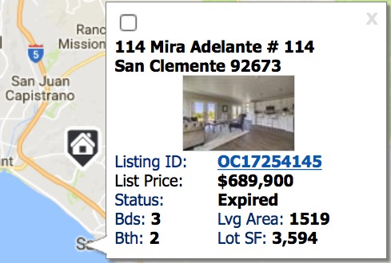
Expired and withdrawn listings also get a ton of attention from Realtors, hoping to convince them to resign a listing agreement. Another thing to remember: you actually are exactly what these Realtors are promising these expired listings. You're a motivated and full-qualified buyer who is ready to go right now and interested in their particular home. This is a huge point of distinction for you and should be emphasized in the very first interaction. If they still have any interest in selling their home, you're EXACTLY whom they want to find!
The best and most direct way to interact with one of these homeowners is to directly knock on their door. Most of the agents that are contacting them are doing so by mail or phone. So a direct approach at their door will set you apart.
Prepare for a positive response, have your introduction letter with you, but know that you'll likely get more rejections than not. If you do get a positive response, don't begin to negotiate or talk numbers. Keep the initial positive conversation light and theoretical. Use this as an opportunity to learn about their current thinking about selling (Why haven't you listed it? When were you thinking about selling? Have you interviewed any agents?) and the house itself (How long have you lived here? What kind of work have you done? What would you change about the house if you could? What are your favorite things about it?). And do NOT forget to compliment their home!
As in all contacts with a homewoner, he focus of the contating the home is to set up a time where the owner will give you a tour. Your focus is NOT to try and put together a deal or lob a trial balloon verbal offer. You simply want to spend some time in the house to see if it deserves to stay on or be removed from your list of possibilities.
It's very likely that your initial conversation with one of these homeowners will include finding out exactly why their home is no longer listed for sale. Pay VERY close attention to what they have to say. Their problem (or problems!) may be something that you're unwilling to solve, such as an unrealistic asking price, a home with way too many structural or design issues, or terms that won't work for you (a short sale approval process that may take too long, a delayed move-in date, problems with title, or any number of other things.).
Lastly, it's possible that they'll want to include a Realtor in the process of dealing with you. It may not be the agent who had the listing, as some sort of conflict or disappointment may be the reason the house isn't on the market any more, but at some point they recognized the value of having a professional involved and they'll be very likely to get one involved again.
Having an agent getting involved isn't a bad thing, at all. There is a very specific process for selling a home and tons of legal requirements and restriction involved. Someone knowledgeable in all of the ins and outs can be a very valuable resource. The key here, however, is to be VERY aware that if there is an agent involved they will have an agency and fiduciary responsiblity to the home seller and not to you. That means that you'll somewhat be on your own!

Step 6: Contact Active Agents Your Preferred Neighborhood
Another great potential source for an off-market home is to reach out to those whose job it is to turn them into on-market homes. Every neighborhood has at least one, sometimes many more than that, Realtors who are actively involved in "farming" and working it to get new listings. They can be a VERY good source given their strong local knowledge and functional domination of the area.
Again, utilize the information available on one of the many online sites to identify which agents have been selling homes in the neighborhood, whether on the buying or listing side. We can also give you a list of homes sold (and the agents involved) for any neighborhood throughout the county. You should look carefully for any trend of agents whose name pops up the most. When you talk to one of these agents, you can also inquire as to their knowledge of other agents that work the neighborhood, especially if the one you're talking to doesn't have any specific homeowners in mind. It may take some finesse to get the information you're seeking, but most agents are very aware of the activity of other agents in the immediate area.
Oftentimes these agents will have "pocket listings," owners who have directly indicated a willingness to sell but, for one reason or another, have declined to formally offer their home on the market. It usually involves some sort of "Well, for the right buyer/offer/price/timing I'd sell, but I don't want to go through the commitment/hassle/process of listing it." As they make it a habit to get to know as many of the owners in their farm and create relationships with them, they will very likely have some good ideas.
For example, if you wanted a home in the Turtle Rock area of Irvine, you'd start with a closed sale like this (with info from the MLS):
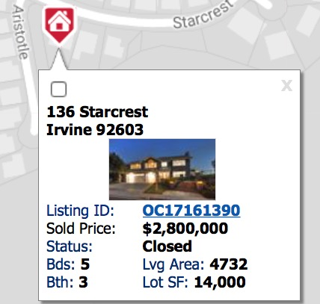
Then the MLS Listing ID shows the agents involved:
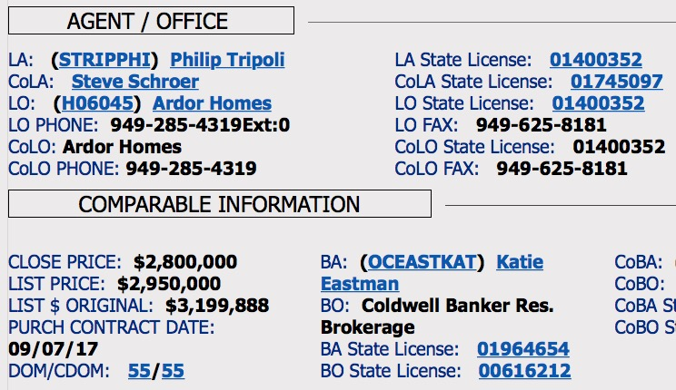
Then you simply call the agents on both sides of the transaction and have a conversation like this:
"Hi there. I'm on a search to find a home that isn't on the market in the same neighborhood that you just closed a sale. I'm fully pre approved for $X and looking for a 4 bedroom, 3 bath home with a 3 car garage and a pool. Do you know of any homes not currently listed in that area that might fit that description?"
Obviously, if you contact listing agents of homes that are still on the market, trying to see what they know about stuff going on in the neighborhood, you won't have a buy-side agent with whom to talk. I was involved in the sale of a home last year where a neighbor had informed the listing agent that they'd be interested in selling if the right buyer came along (meaning pay a lot for the home but not formally list it) and the agent did sell that house to someone who wasn't interested in their listing.
One thing to realize about this move, however, is that you will almost certainly have to work with the agents in order to approach one of these sellers. The Realtor will (rightly) see this as a chance to turn your search into a commission-earning opportunity. This isn't necessarily a bad thing, of course, just make sure to work out the details of the representation and the compensation beforehand. Insist that any agreement be for a specific home and not a more far-reaching buyer agreement. It should be for a one-time deal.
Furthermore, as you have already done your financial and needs-list homework, have already evaluated everything on the market, and even begun to do some searching on your own, aggressively negotiate the commission rate. You're not asking them to tour you through the county nor do a bunch of additional work on your behalf. Most of the work that they usually do will have been done and you’re asking them for knowledge that they probably already have in mind. It's also possible that your search may spur them to do some further searching on your behalf. That's a great outcome: you've essentially just acquired a knowledgeable and skilled assistant!

Step 7: Contact Rental Property Owners
Being a landlord is not easy and you may find one who is ready to part with their home. They therefore should be included in any serious search for an off-market home.
The first and easiest type of landlord or property owner to contact is one who is currently offering their home for lease. Simply go to all of the various websites that offer home rentals and initiate the conversation. This might occur with the listing agent, property manager, or the owner themselves. Obviously, the starting point of the conversation is something like this:
"I understand that you're offering your home for lease, but would you be interested in discussing a sale? (Then launch into your script)"
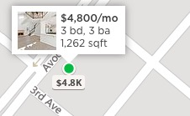
Although these types of homeowners are the easiest to identify and contact, they're also the least likely ones to sell. By having their home listed for lease, they're already signaling an interest in NOT selling. But, it's certainly worth a try and you never know what you will discover.
If you end up speaking with an agent or property manager, certainly inquire as to their knowledge of other homeowners in the neighborhood who might be interested in selling. Remember, you are now in the business of turning over rocks to find a hidden gem. Conversations with people who may be in a position to point out the right rock for you might just be the way you find what you're looking for. Contacting rental property managers directly, asking them about their clients, especially if they focus on a specific area, is another part of this puzzle. Typically, rental property management companies are small mom and pop shops, given that most of that business is for commercial or vacation properties.
The second type of landlord or property owner to contact is much tougher to find and contact. These are simply folks are absentee owners, whose homes are occupied by someone else (although not necessarily a tenant). The idea here is that they may be tiring of owning the property or have an interest in cashing out any equity gains that they have accrued. If they've a tenant in the property with a long-term lease agreement, possession of the property would be subject to the termination date of the lease or a negotiation with the tenant themselves. You might end up finding a willing seller of the right property, but have to wait until the current tenants move out!
There are many services that can provide contact and other information on absentee owners. ListSource.com and title companies can be a place to get this information. We can refer to you a good title rep who can be of assistance, as well. It's likely they'll be difficult to reach in person or over the phone, so you'll end up mailing your introduction letter - probably more than once.
Your primary avenue for contacting these owners will be via the mail or phone, although if they live locally, a direct door knock will certainly work. Make sure your mail piece is unique and sure to get attention.
Just like with expired listings, Realtors also consistently market to absentee owners. So definitely be prepared for that. But, just like with anyone else who wants to sell, you could be exactly what they're looking for: a pre approved buyer who has prequalified (at some level) their home. That's the key thought to keep in your mind whomever you are contacting: "I could be EXACTLY what this homeowner is looking for!"
Step 8: Directly Contact Home Owners
The last type of homeowner you should plan on contacting are the rest of the ones who live in the homes and neighborhood that you'd potentially be interested in. This involves literally going from house to house, from owner to owner, in order to find what you could be looking for.
An online data source like Zillow or Trulia are essential for this step.
Assuming that you mastered Step 3 above, knowing where you want to live and exactly what type of house it should be, carefully identify online all of the potentials. Open Zillow, focus on the neighborhood, and then move from house to house, taking note of the general price range and property description that shows up.
For example, if you wanted to live on the west side of the bay in Newport Beach in a sub-$1,700,000 3-bedroom ranch house that's under 1,700 square feet, a possible target would look like this:
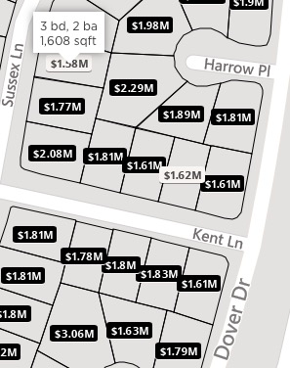
Or this:
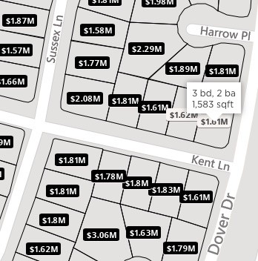
Or, if you wanted to live in Orange in a sub-$750,000 4-bedroom home that's around 2,000 square feet, a possible target would look like this:
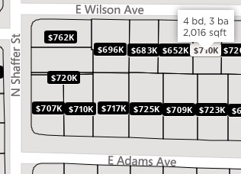
Or this:
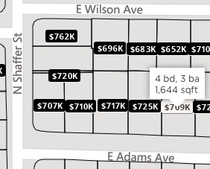
You get the idea.
Clicking on that particular property will give you even more information about it and possibly even pictures. If you do a general search on the property address, you may find out more information, such as previous listing information and even more pictures. Then drive by every single home you've identified and evaluate it. The whole point is to narrow the long list to a handful of targets on which to focus.
Then you need to start to contact the owners.
The most impactful and direct way to talk to one of these homeowners is to knock on their door. Have your script down, a copy of the letter you've prepared, and then hit the bricks. As you well know, folks knocking on a door aren’t the most welcome of things, but it's a great way to make first contact. It's also a way to make a strong first impression as well; it's impossible not to notice that you are VERY serious.
Of course, the likelihood of a positive hit is low. So expect a bunch of no's. Or worse.
But you also might get a positive response. In fact, the best mind space to be in while door knocking is to expect a positive result. If this does happen, don't begin to negotiate or talk numbers. Keep the initial positive conversation light and theoretical. Use this as an opportunity to learn about their current thinking about selling (Why haven't you listed it? When were you thinking about selling? Have you interviewed any agents?) and the house itself (How long have you lived here? What kind of work have you done? What would you change about the house if you could? What are your favorite things about it?). And do NOT forget to compliment their home!
If door knocking efforts are unsuccessful, you can leave your introduction letter on their door stoop or mail it to them. You may have to do this a few times in order to get a response.
As in all contacts with a homeowner, he focus of the contacting the home is to set up a time where the owner will give you a tour. Your focus is NOT to try and put together a deal or lob a trial balloon verbal offer. You simply want to spend some time in the house to see if it deserves to stay on or be removed from your list of possibilities.
Step 9: Tour the Home
This is where things get serious. All of your efforts so far in Steps 4 through 9 come down to this. The whole point of the tour is to compare the house with the homework you've already done in Step 3. It's no different than walking through an open house or viewing an on-market home with an agent. Other than doing it with the homeowner, it's something you've already done many times before.
Having the owner with you can be a big advantage: they know more about the house than anyone else.
It also can be a disadvantage: they may have strong emotional connections with it and may get into far more personal things than would otherwise be appropriate.
Be careful to NOT offend them. You may hate their custom awful cabinets or want to laugh at some other detail but don't do it. Say only positive things and keep mental notes about the negative ones.
You probably don't need to be reminded of the question to be asking yourself while walking through:
"Is this a house that could be my home?"
Step 10: Write an Offer and Negotiate a Deal
This is the final step. Once you've found the home for you, make an offer on it.
Use the services of whomever you've identified from Step 4 to write a formal offer, even if you've already put together a handshake deal with the homeowner.
When negotiating, the same things apply to buying an off-market home as with anything else. Be fully versed on what is the likely range of current value - recent comparable sales with adjustments for whatever differences exist and base your offer upon that. Of course, you'll rightly intend to be on the low side and the seller will prefer the high side.
Definitely utilize any knowledge you gained during your various conversations with the homeowner, as well. There's a world of difference in a starting point of "We don't have to sell and would only do so if it was REALLY worth our while" and "Turns out we need to get out of this house by month's end." One clue as to their level of motivation, unless they directly tell you differently, is that they haven't already listed it and you can therefore expect to NOT get a price that's significantly below the market.
Expect a more complicated escrow than would be with a home that's currently on the market. In most cases, the owners of a listed home have begun make preparations for moving. This would include things that need to be fixed or addressed within the house, as well as moving out all of their stuff. If someone hadn't been getting ready to sell, as will likely be the case of an owner-occupied off-market home, this will certainly take some time. They'll probably want a long-than-usual escrow period to get all of this done.
Free advice: Give it to them.
And some problems could be discovered that a Realtor would have found in the process of readying the home for sale, such as structural or termite or electrical or whatever issues. Fortunately for you, all of these things can used in your favor in the negotiations. You can expect that they'll likely pay for none of these things, as you're the one that approached them, but that doesn't mean that you can't consider them.
"You want a 70 day escrow and for me to handle the termite work, the peeling paint outside, the leaky faucet and the non-working electrical outlets? Of course I will, but then we need to offset all of those things by $X on the price..."
Finding an buying an off-market property is not likely to be a way to get some sort of fantastic deal and so you shouldn't expect it. Nor should your final go/no-go decision be based upon some arbitrary discount percentage. Remember, it's a sellers market - which is why you've resorted to finding an off-market property in the first place.
Final Thoughts
Obviously, this is NOT an easy process. The 5,500+ words here are literally just the beginning. As in anything else, the keys to success are preparation and execution; and these steps encompass lots and lots of work to accomplish both.
There are professionals who are working most of these steps 7 days a week, 12 hours or more every single day to accomplish the same goal in order to earn a living. You will be competing against them. Do NOT forget one key difference, however: You have the motivation and means to close a sale. The Realtors who you'll be competing against to find these potential home sellers will then, if they're successful finding one, try to then find someone like you!
As you can also see, some of these steps require the assistance of professionals. it's almost impossible to successfully complete this process without an attorney or Realtor to handle the paperwork and a Realtor to supply you with some information that is most easily found on the MLS (only members of a board of Realtors can get access to the MLS). Ask a friend for a referral or contact us - we'd be happy to assist.
Final Final Thought
If you decide this is too much (whether you've begun the process or decided upfront that it's too big of a bite to swallow), this is a service we offer as part of our Wise Home Buyer program. Not only will we help you find a home (on-market or off), this program combines the Realtor and mortgage loan broker services to save you money and time!
Thank you!

Michael Hausam

Phone: 949.478.1867
Toll Free: 844.287.0009
Fax: 800.287.0009
Email: Info@HausamGroup.com
Instagram: @TheHausamGroup
Website: www.HausamGroup.com

